# **Assignment 1 – Experience Interactions!**

## Part 1 Identifying Interactions

This was my first week in Canada and I got to experience and interact with a lot of new interfaces. Some made my job easy, whereas some were a bit difficult to figure out. Below are some of the interfaces that really caught my attention

### Presto Machine/Cards

The first thing I got after reaching Canada was my presto card as I need it to transit from my house to college. It was pretty easy for me to get my hands on it as it was easily available at my nearest Shoppers Drug Mart. Even the application of the card is pretty user friendly, all you need to do is tap it on the machine once you get into the bus, which is much easier compared to digging your purse trying to find loose change. The machine emits a beep notifying the user that the transaction has been successful. It also displays the balance amount you have on your card.

### Self-Checkout Counters

The next big task I had at hand after moving to my new home was getting all my bare necessities, so like every other student I went to Dollarama to get all my basic essentials. While billing I encountered the self-checkout counters where you can scan your items and make your payment without any employee help. The concept of self-checkout is convenient in terms of reducing labor and reducing the rush at checkout, although I struggled a bit while trying to find the right buttons to press on. Scanning the items was easy and the machine interacted by displaying the price of the items that was being scanned along with a ding sound. Once all the items are checked, the machine will display the total amount and you can proceed to pay. Two drawbacks I found in this machine is its pretty difficult to cancel an item that you checked out and that paying in cash is also a menace. With a few tweaks here and there, these counters can be really efficient in revolutionizing sales industry.

### Tap and Pay / Mobile wallets

Another cool app which I came across was the tap and pay app, where you can configure your credit/debit cards to your mobile phones. The app definitely makes payment so much easier. It takes minimum effort to open the app on your phone. You can directly access it from the notification bar and select your card to make the payment. Setting up your card also takes very little time and effort, all you need to do is fill in the details that are requested and the app provides a tutorial on how to use it. The app also helps you know your account balance.

### Google Maps

If you ask me which is the app that I’ve been using the most after coming to Canada, it’s Google Maps. The app is very user friendly and its very easy to navigate through the app. All you need to do is enter the destination and the app will provide the fastest route. It will also provide details about the buses if you are travelling on bus. Although there are other map apps like transit, I find google maps more user friendly. Apart from just showing routes, google maps has a bunch of other features like sharing your live location with someone, saving locations (I find this very useful while you park your car somewhere and have a tough time trying to figure out where you parked it.) and making lists of locations you want to visit. Although all these fun features are available, I feel that only a very limited number of people use them as they primarily only use them for navigation.

### WhatsApp

Another app that I’ve been using a lot recently is WhatsApp. Being away from my friends and family, WhatsApp has helped me to shorten the distance. The app enables audio and video calls which allows you to stay connected to your loved ones. It is very user friendly and can be used by people of all ages. The app even runs in different languages hence allows you to change it to your native language. It has three separate tabs one for chat, status/stories and call logs which helps to sort it into three categories. One feature that I really like is the search bar which helps you to easily find a contact. The app will have a ringtone to notify the user for any incoming messages or calls. While sending messages the app will show one tick to show that the message has been sent, two ticks to show that it has been delivered and the ticks will turn blue to show that the message has been read hence making user experience even better

## Part 2: In-Depth Analysis

For the in-depth analysis I would like to explain about my experience with Presto Machine/Cards.

The presto app makes the application of presto cards even more practical. The app has a very simple design, which helps to avoid any confusion.

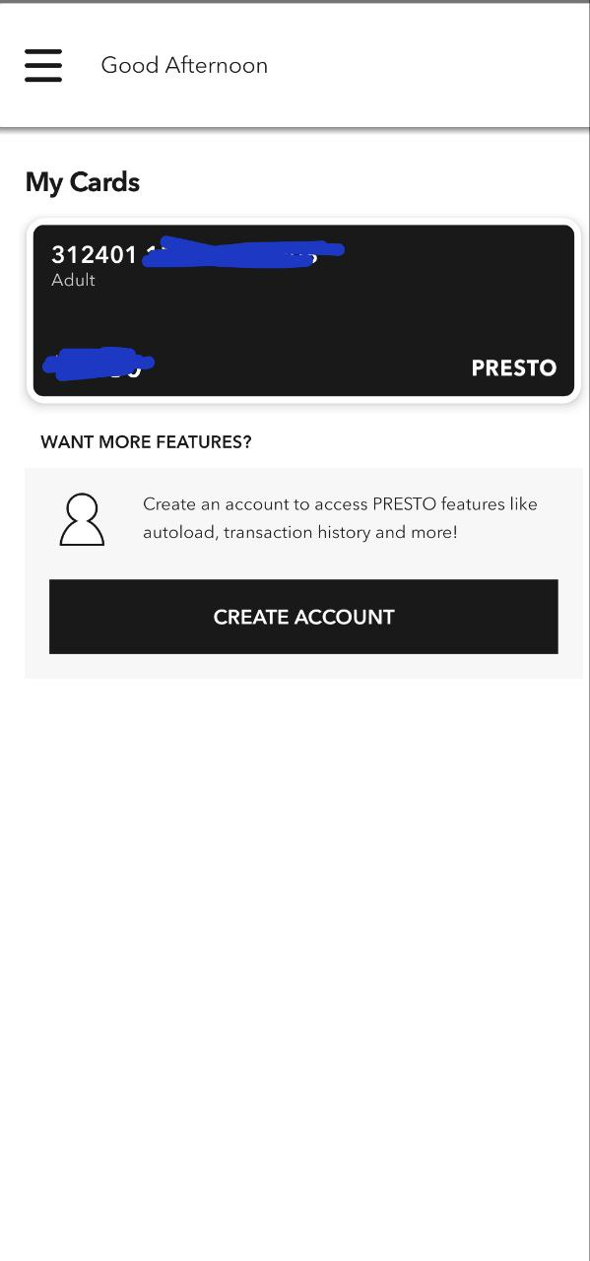

You can simply add your card by typing in your card number and the app will display the card details along with the balance amount. The buttons in the app have its functionality written (for example, load funds, load new pass etc.). You can load funds as per your needs by entering the card details. Once you register to the app using your email ID you can also track your presto card usage. The app also allows you to purchase monthly passes based on your needs. It also allows you to report incase your presto card is stolen or lost.

Similarly, there is a hamburger menu in the main page with more options

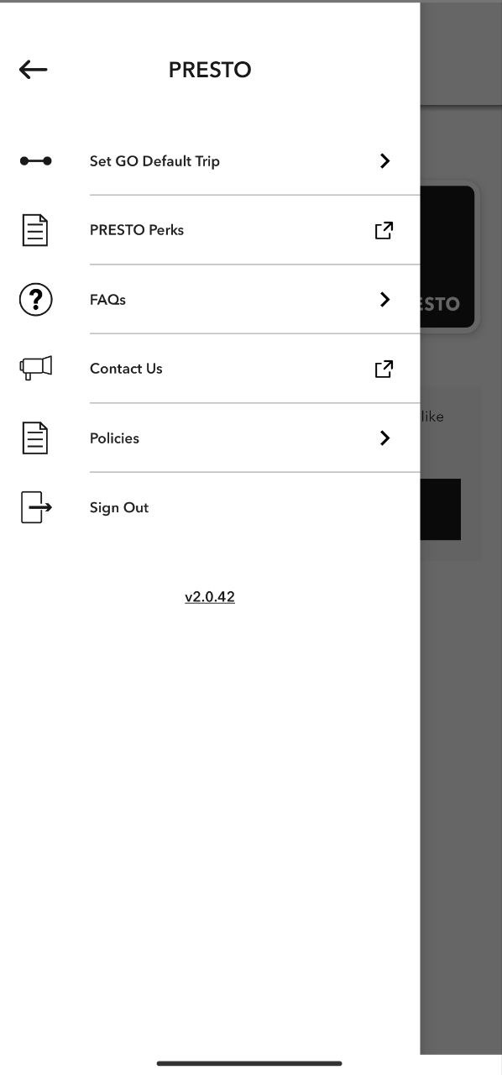

The hamburger menu options are depicted with both icons as well as words which makes it easier for people who is not comfortable with English.

I liked the app for its simplicity. Instead of crowding the main page with all the functionalities, there are different sections and subsections for each requirement. In short, the app provides a solution for all your presto card needs without having to go to any store.